**Tastefully Simple Fundraiser**

MSSOD Dancers will host a Tastefully Simple Fundraiser during the month of April. Info will be posted in the lobby. Thank you **Patty** **Bardeen** for offering this fundraiser to minimize costume costs.

**Marilyn Schneider School of Dance**

***April 2022***

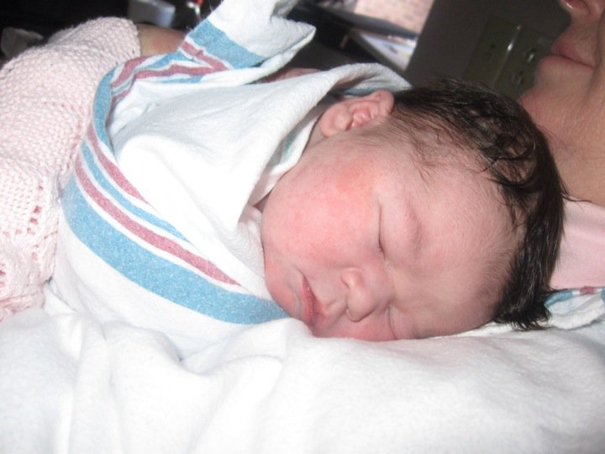

**NYCDA RESULTS**

**Our MSSOD Elite Travel dancers traveled to Buffalo to attend the NYCDA Workshop and Competition. We are very proud of our results. We received the “Class Act Award” for the studio who portrays a “class act” in all they do! Scholarships were won by Tatiana, Nick, Victoria and Nathan. Finalists for scholarships included Averie, Sarah, Sophia and Lexi. Congratulations to all. Also, congratulations on all of the Platinum, High Gold and Gold achievements as well as all of the special awards. They are listed at the LP studio.**

***Costume Balances***

***Thank you to all who have been asking about costume balances. I hope to have the majority of bills ready by April 30th.***

**APRIL DANCES**

Spring has arrived and hopefully the warm weather will remain with us. That means recital is getting closer. Costumes are arriving and there are sequins and rhinestones everywhere! Some of my funnier memories as a teacher are getting the little ones to focus in class and stop picking up sequins off the floor. When they try on their costumes and see themselves in the mirror, the look on their faces is precious. We will soon be trying on costumes. Keep in mind costumes are not made exactly to students measurements so minor alterations may be necessary. Costumes will be handed out after balances are paid in full. When costumes are taken home please: write names on all costume pieces and accessories, hang costumes to allow wrinkles to fall out, attach all the accessories and keep all items together.

HAPPY SPRING-HAPPY RECITAL!

**MARILYN**

**Dance Masters of America Performing Arts Competition** will be held in Cicero, NY on April 8-10. Our travel team, house team and Pee Wee members will be traveling for this major dance event. The results will be posted in the studio.

***Please mark your calendars for these important dates.***

***Recital pictures*** *will be taken* ***Monday June 6th*** *and* ***Tuesday June 7th*** *at the studio. Photo schedule is posted on the website and in the waiting room. Studio rehearsal times are posted in the lobby.*

***SPIRIT WEEK*** is ***NATIONAL DANCE WEEK***

***Monday* - Old Costume Day *Tuesday* - Sports Day *Wednesday* - 80's Flashback Day**

***Thursday* - Crazy Hair Day *Friday* - PJ Day *Saturday* - Disney Day**

**Page Two**

***WE HAVE A BUSY TIME AHEAD OF US WITH COSTUMES, PICTURES, REHEARSALS, REGISTRATION FOR SUMMER AND THE 2021-2022 RECITAL. WITH THIS BUSY TIME COMES A LOT OF QUESTIONS AND WE ARE HERE TO HELP. CALL ME AT 227-6413 OR EMAIL ME AT MECACCAMISE@GMAIL.COM ANYTIME.***

**LOST AND FOUND – The box in the lobby under the coat rack contains lost and found items. It is filling up. Please take a minute to check it and see if anything belongs to you. Items left will be donated to Goodwill during Easter break.**

**REGISTRATION** Classes *for this season are closed but we are thinking of our summer dance session and the 2022-2023 dance year already. Registration for the fall classes will begin April 3rd. Interested in dancing this summer? Summer registration will be out shortly. We will offer a few camps as well as our regular dance program. All dancers are encouraged to dance in the summer.*

**CRAZY WEATHER** Mother Nature has been playing lots of games with us in Western New York this year. While our goal is to remain open, for the safety of our staff and students we have found it necessary to close two times this season due to poor weather. All classes missed for any reason can be made up but not necessary to make up for Perfect Attendance.



**Proper Dancewear It's important that students wear proper dance clothes and shoes along with having their hair tightly pulled back and off their face. Please come to class prepared!!**

*You don't always get what you wish for but you get what you work for!*

Teachers are deciding on the Outstanding Achievement Award recipients. All students are eligible. Ask your teacher how you can earn one!!

***Academic achievers***

*Be sure to turn in a copy of your child’s report card by May 1st to be recognized in our program as academic achievers. Excellence in school work is a definite plus for dancers.*

**Family and Business Program Advertising**

Show your support for the dancers in your life. Place an ad in the Recital Program. Include personal messages and photos to let the dancer in your family know how proud you are of him or her.

Business advertising is also welcome. More than 1,000 residents will view your ad. Please support our efforts to give dancers memorable keepsakes. The recital program is funded by these ads. Ad forms will be available this month.

**CONGRATULATIONS** to our students who participated in their school musicals this year.

42nd Street – **Danielle Sapor** and **Nathan Litz**

Spelling Bee – **Madi B**oura and **Jamie Fetzner**

Beauty and the Beast – **Nick Guarino, Sam Muscato, Sarah Muscato**

***ENCANTO BREAK CAMP***

Thursday April 21st 9-12pm

Dancing-Crafts-Games-Snacks

Sign up at the LP studio

**Please Note**

**When there is an account balance due for tuition or costumes, the costume (s) will be retained at the studio until the balance is paid and the account is clear.**

**EASTER BREAK**

The studio will be closed Friday, April 15-24th.

We will open Monday April 25th.

***RECITAL TICKETS***

*Recital tickets will be available after May 1st. Each family is responsible for selling 5 tickets or making a $85 donation. This covers the school rental, extra insurance, scenery, lighting and sound equipment, etc.*

***POPCORN FUNDRAISER***

***Congratulations to the 30 dancers who participated in our popcorn fundraiser. Your profits will be deducted from your costume account.***

***Congratulations to our prize-winning top sellers:***

***1st – Aria L. ($100 prize), 2nd -Charlotte R. ($50 prize), 3rd – Kendall F. ($25 prize), 4th – Graceanne D. ($15 prize), 5th – Brianna F. ($10 prize).***

**ABSENTEEISM**

**It is the student’s responsibility to attend all classes therefore reductions are not given for missed classes.**

**Attendance Awards**

Awards for perfect attendance are presented on stage at our performance. To qualify all lessons must be made up by June 1st. We allow no make ups in or for the month of June. All rehearsals are also mandatory. Please remind dancers of this!

With the warm weather also comes Spring sports season. We ask everyone to remember that classes are now working on recital numbers thus we need dancers in class.

**PRACTICE!!**

**PRACTICE!!**

**PRACTICE!!**

We are entering recital mode. Dancers should be practicing their dances daily. Like any other sport, your dancer has a responsibility to themselves as well as to their teammates. You are encouraged to purchase your music cd for $2. Please ask your teacher to order.

**Page Three**

[www.msschoolofdance.com](http://www.marilynschneiderschoolofdance.com)

*RECITAL TEES*

Recital t-shirts with all of the performers names on them will be here shortly. These shirts are worn often – at Recital, Sea Breeze, fundraisers, etc...